1. git --version

2. git init

This creates a hidden folder, .git , which contains the plumbing needed for Git to work.

3. git status

Review the resulting list of ﬁles;

4. git add <file/directory name #1> <file/directory name #2> < ... >
If all ﬁles in the list should be shared with everyone who has access to the repository,

a single command will add everything in your current directory and its subdirectories:
git add .
This will "stage" all ﬁles to be added to version control, preparing them to be committed in your ﬁrst commit.

Commit all the ﬁles that have been added, along with a commit message:
5. git commit -m "Initial commit"
This creates a new commit with the given message. A commit is like a save or snapshot of your entire project.

Adding a remote
To add a new remote, use the git remote add command on the terminal, in the directory your repository is stored
at.
The git remote add command takes two arguments:
1. A remote name, for example, origin
2. A remote URL, for example, https://<your-git-service-address>/user/repo.git
6. git remote add origin https://<your-git-service-address>/owner/repository.git

________________________________________________________________________________

Clone a repository

cd <path where you would like the clone to create a directory>
git clone https://github.com/username/projectname.git

________________________________________________________________________________

Sharing code

git init --bare /path/to/repo.git

git remote add origin ssh://username@server:/path/to/repo.git

git push --set-upstream origin master
Adding --set-upstream (or -u ) created an upstream (tracking) reference which is used by argument-less Git commands, e.g. git pull.
________________________________________________________________________________
Setting your user name and email

git config --global user.name "Your Name"

git config --global user.email mail@example.com

Remove a global identity

git config --global --remove-section user.name
git config --global --remove-section user.email
________________________________________________________________________________

Learning about a command

git status –help

git help status

git checkout -h
________________________________________________________________________________

Set up SSH for Git

Linux open your Terminal

check to see if you have any existing SSH keys. List the contents of your ~/.ssh directory:

$ ls -al ~/.ssh
# Lists all the files in your ~/.ssh directory

if you already have a public SSH key. By default the ﬁlenames of the public keys
are one of the following:

id_dsa.pub
id_ecdsa.pub
id_ed25519.pub
id_rsa.pub

If you see an existing public and private key pair listed that you would like to use on your Bitbucket, GitHub (or similar) account you can copy the contents of the id_*.pub ﬁle.

create a new public and private key pair with the following command:

$ ssh-keygen

Add you SSH key to the ssh-agent. Notice that you'll need te replace id_rsa in the command with the name of your private key ﬁle:

$ ssh-add ~/.ssh/id_rsa
________________________________________________________________________________
Git Installation

$ apt-get install git
________________________________________________________________________________

Git Log

git log

will display all your commits with the author and hash in reverse chronological order – that is, the most recent commits show up ﬁrst.

Prettier log:
git log --decorate --oneline --graph

Since it's a pretty big command, you can assign an alias:
git config --global alias.lol "log --decorate --oneline –graph"

To use the alias version:
# history of current branch :
git lol

# combined history of everything in your repo :
git lol --all

Colorize Logs:
git log --graph --pretty=format: ' %C(red)%h%Creset -%C(yellow)%d%Creset %s %C(green)(%cr)%C(yellow)<%an>%Creset '

The format option allows you to specify your own log output format:
Parameter Details
%C(color_name) option colors the output that comes after it
%h or %H abbreviates commit hash (use %H for complete hash)
%Creset resets color to default terminal color
%d ref names
%s subject [commit message]
%cr committer date, relative to current date
%an author name

Oneline log
git log --oneline
//will show all of your commits with only the ﬁrst part of the hash and the commit message.

git log -2 –oneline //if you wish to list last 2 commits logs
Filter logs:
git log --after '3 days ago'

git log --after 2016-05-01

An alias to --after is --since .
Flags exist for the converse too: --before and --until .

You can also ﬁlter logs by author . e.g.
git log --author=author

Show the contents of a single commit:

git show 48c83b3
git show 48c83b3690dfc7b0e622fd220f8f37c26a77c934
________________________________________________________________________________

Working with Remotes

Show information about a Speciﬁc Remote:
git remote show origin

Print just the remote's URL:
git remote get-url origin

Set the URL for a Speciﬁc Remote:
git remote set-url remote-name url

Get the URL for a Speciﬁc Remote
git remote get-url <name>

By default, this will be
git remote get-url origin

Changing a Remote Repository

git remote set-url <remote_name> <remote_repository_url>
Example: git remote set-url heroku https://git.heroku.com/fictional-remote-repository.git
________________________________________________________________________________

Staging

Staging All Changes to Files:

git add -A
or
git add .

Show Staged Changes:
git diff --cached
Staging A Single File:

git add <filename>

Stage deleted ﬁles:
git rm filename

To delete the ﬁle from git without removing it from disk, use the --cached ﬂag
git rm --cached filename
________________________________________________________________________________

Ignoring Files and Folders

in a .gitignore ﬁle:

# Lines starting with `#` are comments.

# Ignore files called 'file.ext'
file.ext

# Comments can't be on the same line as rules!
# The following line ignores files called 'file.ext # not a comment'
file.ext # not a comment

# Ignoring files with full path.
# This matches files in the root directory and subdirectories too.
# i.e. otherfile.ext will be ignored anywhere on the tree.
dir/otherdir/file.ext
otherfile.ext

# Ignoring directories
# Both the directory itself and its contents will be ignored.
bin/
gen/

# Glob pattern can also be used here to ignore paths with certain characters.
# For example, the below rule will match both build/ and Build/
[bB]uild/

# Without the trailing slash, the rule will match a file and/or
# a directory, so the following would ignore both a file named `gen`
# and a directory named `gen`, as well as any contents of that directory
bin
gen

# Ignoring files by extension
# All files with these extensions will be ignored in
# this directory and all its sub-directories.
*.apk
*.class

# It's possible to combine both forms to ignore files with certain
# extensions in certain directories. The following rules would be
# redundant with generic rules defined above.
java/*.apk
gen/*.class

# To ignore files only at the top level directory, but not in its
# subdirectories, prefix the rule with a `/`
/*.apk
/*.class

# To ignore any directories named DirectoryA
# in any depth use ** before DirectoryA
# Do not forget the last /,
# Otherwise it will ignore all files named DirectoryA, rather than directories
**/DirectoryA/

# This would ignore
# DirectoryA/
# DirectoryB/DirectoryA/
# DirectoryC/DirectoryB/DirectoryA/
# It would not ignore a file named DirectoryA, at any level
# To ignore any directory named DirectoryB within a
# directory named DirectoryA with any number of
# directories in between, use ** between the directories
DirectoryA/**/DirectoryB/
# This would ignore
# DirectoryA/DirectoryB/
# DirectoryA/DirectoryQ/DirectoryB/
# DirectoryA/DirectoryQ/DirectoryW/DirectoryB/

# To ignore a set of files, wildcards can be used, as can be seen above.
# A sole '*' will ignore everything in your folder, including your .gitignore file.
# To exclude specific files when using wildcards, negate them.
# So they are excluded from the ignore list:
!.gitignore

# Use the backslash as escape character to ignore files with a hash (#)
\#*#

Exceptions in a .gitignore ﬁle:

*.txt
!important.txt
The above example instructs Git to ignore all ﬁles with the .txt extension except for ﬁles named important.txt .

Ignore ﬁles that have already been committed to a Git repository:

git rm --cached <file>

This will remove the ﬁle from the repository and prevent further changes from being tracked by Git. The --cached option will make sure that the ﬁle is not physically deleted.

Clear already committed ﬁles, but included in .gitignore:

# Remove everything from the index (the files will stay in the file system)
$ git rm -r --cached .

# Re-add everything (they'll be added in the current state, changes included)
$ git add .

# Commit, if anything changed. You should see only deletions
$ git commit -m 'Remove all files that are in the .gitignore'

# Update the remote
$ git push origin master
________________________________________________________________________________

Git Diff

Show differences in working branch:
git diff

Show changes between two commits:
git diff 1234abc..6789def # old new

Show the changes made in the last 3 commits:
git diff @~3..@ # HEAD -3 HEAD
Note: the two dots (..) is optional, but adds clarity.

Show differences for staged ﬁles:
git diff --staged
git diff --cached
git status -v

Show differences for a speciﬁc ﬁle or directory
git diff myfile.txt

Show dierences between current version and last version
git diff HEAD^ HEAD
________________________________________________________________________________

Undoing

Return to a previous commit:
git checkout 789abcd
//To temporarily jump back to that commit, detach your head

To roll back to a previous commit while keeping the changes:
git reset --soft 789abcd

To roll back the last commit:
git reset --soft HEAD~

To permanently discard any changes made after a speciﬁc commit, use:
git reset --hard 789abcd

To permanently discard any changes made after the last commit:
git reset --hard HEAD~

Undo changes to a ﬁle or directory in the working copy.
git checkout -- file.txt

Used over all ﬁle paths, recursively from the current directory, it will undo all changes in the working copy.
git checkout -- .

To only undo parts of the changes use --patch . You will be asked, for each change, if it should be undone or not.
git checkout --patch -- dir

To undo changes added to the index.
git reset --hard

Without the --hard ﬂag this will do a soft reset.
________________________________________________________________________________
Merging

git merge incomingBranch

git merge --abort
________________________________________________________________________________
Committing

git commit -m "Commit message here"

git commit -am "Commit message here"
Note that this will stage all modiﬁed ﬁles in the same way as git add --all .

If your latest commit is not published yet (not pushed to an upstream repository) then you can amend your commit.
git commit –amend -m "New commit message"
________________________________________________________________________________
Aliases

git config --global alias.ci "commit"
git ci -m "Commit message..."
________________________________________________________________________________
Conﬁguration

Parameter Details
--system Edits the system-wide conﬁguration ﬁle, which is used for every user (on Linux, this ﬁle is located at $(prefix)/etc/gitconfig )
--global Edits the global conﬁguration ﬁle, which is used for every repository you work on (on Linux, this ﬁle is located at ~/.gitconfig
--local Edits the respository-speciﬁc conﬁguration ﬁle, which is located at .git/config in your repository; this is the default setting

Change the core.editor conﬁguration setting.
$ git config --global core.editor nano

Auto correct typos
git config --global help.autocorrect 17

To see the current conﬁguration.
$ git config --list

To edit the conﬁg:
$ git config <key> <value>
$ git config core.ignorecase true

If you intend the change to be true for all your repositories, use --global
$ git config --global user.name "Your Name"
$ git config --global user.email "Your Email"
$ git config --global core.editor vi
________________________________________________________________________________

Branching

Goal Command
List local branches git branch
List local branches verbose git branch -v
List remote and local branches git branch -a OR git branch --all
List remote and local branches (verbose) git branch -av
List remote branches git branch -r
List remote branches with latest commit git branch -rv
List merged branches git branch --merged
List unmerged branches git branch --no-merged
List branches containing commit git branch --contains [<commit>]

To create a new branch, while staying on the current branch, use:
git branch <name>

The branch name must not contain spaces and is subject to other speciﬁcations listed here. To switch to an existing branch :
git checkout <name>

To create a new branch and switch to it:
git checkout -b <name>

Delete a remote branch
git push origin --delete <branchName>

Delete a branch locally
$ git branch -d dev
$ git branch -D dev

Rename the branch you have checked out:
git branch -m new_branch_name

Rename another branch:
git branch -m branch_you_want_to_rename new_branch_name
________________________________________________________________________________

Pulling
When you are working on a remote repository (say, GitHub) with someone else, you will at some point want to share your changes with them. Once they have pushed their changes to a remote repository, you can retrieve those changes by pulling from this repository.

git pull

You can pull changes from a diﬀerent remote or branch by specifying their names
git pull origin feature-A
________________________________________________________________________________
Cloning Repositories
Shallow Clone
Cloning a huge repository (like a project with multiple years of history) might take a long time, or fail because of the amount of data to be transferred. In cases where you don't need to have the full history available, you can do a shallow clone:
git clone [repo_url] --depth 1

to instead get the last 50 commits:
git clone [repo_url] --depth 50

Regular Clone
git clone <url>
git clone <url> [directory]

Clone a speciﬁc branch
git clone --branch <branch name> <url> [directory]
________________________________________________________________________________
Renaming

Rename Folders
git mv directoryToFolder/oldName directoryToFolder/newName

Rename a local and the remote branch
git checkout old_branch
git branch -m new_branch
git push origin :old_branch
git push --set-upstream origin new_branch

Renaming a local branch
git branch -m old_name new_name
_______________________________________________________________________________
Pushing
General syntax
git push <remotename> <object>:<remotebranchname>

Example
git push origin master:wip-yourname

Will push your master branch to the wip-yourname branch of origin (most of the time, the repository you cloned from).

Delete remote branch
Deleting the remote branch is the equivalent of pushing an empty object to it.
git push <remotename> :<remotebranchname>

Example
git push origin :wip-yourname

Will delete the remote branch wip-yourname

Instead of using the colon, you can also use the --delete ﬂag, which is better readable in some cases.
Example
git push origin --delete wip-yourname

git push --set-upstream origin master
________________________________________________________________________________
Show

For commits:
Shows the commit message and a diﬀ of the changes introduced.
Command Description
git show shows the previous commit
git show @~3 shows the 3rd-from-last commit
________________________________________________________________________________

Git Remote

Display Remote Repositories:
$ git remote
$ git remote -v

Change remote url of your Git repository:
git remote set-url origin https://localserver/develop/myrepo.git

Remove a Remote Repository:
git remote rm dev

Add a Remote Repository:
git remote add <name> <url>

Rename a Remote Repository:
git remote rename dev dev1
________________________________________________________________________________
Code with Harry Notes:

- git status
- git init
- git add --a || git add . (working dir ==> staging area)
- git add file1.txt file2.txt
- git commit -m “Initial commit” (staging area ==> repository)
- git log (get all commit logs)
- git clone <url of repo> foldername
- rm -rf .git (remove .git init file)
- touch .gitignore
- view .gitignore (this file contains list of file or directories to be ignored)(blank folder is by default ignored)
- git diff (it will be empty if no difference)
- git diff --staged (to compare current staged file with previous commit)
- git rm file.txt (remove from staged)
- git mv file.txt dir/dir2/ (move + staged)
- git mv file.txt newName.txt (rename +staged)
- git rm --cached file.txt (then add that file in .gitignore) (Untrack a file)
- git log (commit hash + Author + Date + Message)
- git log -p (log + changes made in each commit) (log +diff)
- git log -p -3
- git log --stat (log + insert/delete info)
- git log --pretty=oneline
- git log --pretty=short
- git log --pretty=full
- git log --since=2.days
- git log --since=2.months
- git log --since=2.years
- git log –pretty=format:”%h--%an”
- git commit --amend (to amend current stage to previous commit)
- git restore --staged file.txt (to unstage file.txt)
- git checkout -- file.txt (to restore to previous commit) (to unmodify the changes)(undo)
- git checkout -f (to loose all new changes)
- git config --global alias.last ‘log -p -1’ (git last ==== git log -p -1)
- git remote (it store url)(to check stored url)
- git remote add origin <url>
- git remote -v (to get stored url and url name)
- git remote set-url origin <new-url>
- git push -u origin master
________________________________________________________________________________
Connect PC with github (SSH)
- ssh -keygen -t rsa -b 4096 -c “neeraj.kumar@berylsystems.com” (let passphrase empty)
- eval $(ssh-agent -s)
- ssh-add ~/.ssh/id_rsa
- tail ~/.ssh/id_rsa.pub (copy this token)
In Github:
- Main Security ==> SSH and GPG Key ==>
Title: Neeraj PC BS.HP_Probook
Key: <paste the token copied>
press Add
- git push.......
________________________________________________________________________________

- git checkout -b branch_name (it will create new branch & switch to it)
- git checkout master (to switch to master branch from current branch)
- git branch (to check all available branches)
- git branch -v (branch name + last commit hash code + messgae)
- git branch --merged (list of merged branches)
- git branch --no-merged (list of unmerged branches)
- git branch -d branch_name (to delete a merged branch)
- git branch -D branch_name (to delete a unmerged branch)
- git merge branch_name (it will merge the given branch to master)
- Conflicts to be handled Manually ==> then git add . And commit it
- git push -u origin branch_name (to push the branch on github)
- git push origin branch_name: newBranch (it will create a new branch newBranch & start tracking from branch_name ON GITHUB)
- git push -d origin branch_name (to delete a branch on github)

________________________________________________________________________________

PIC Notes
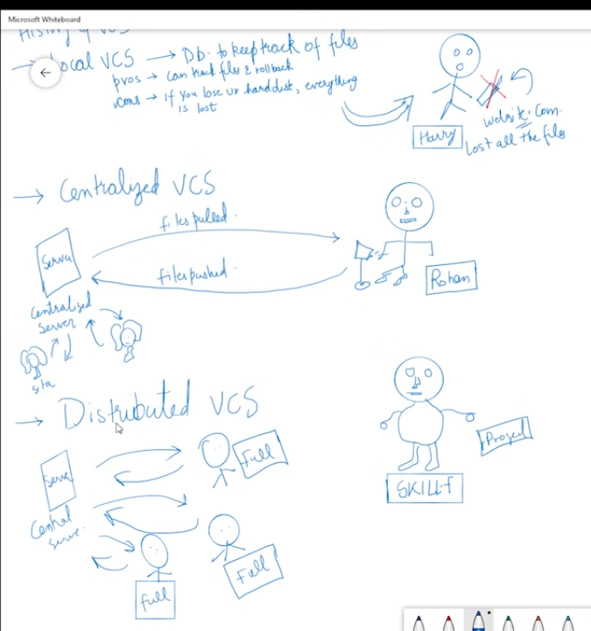

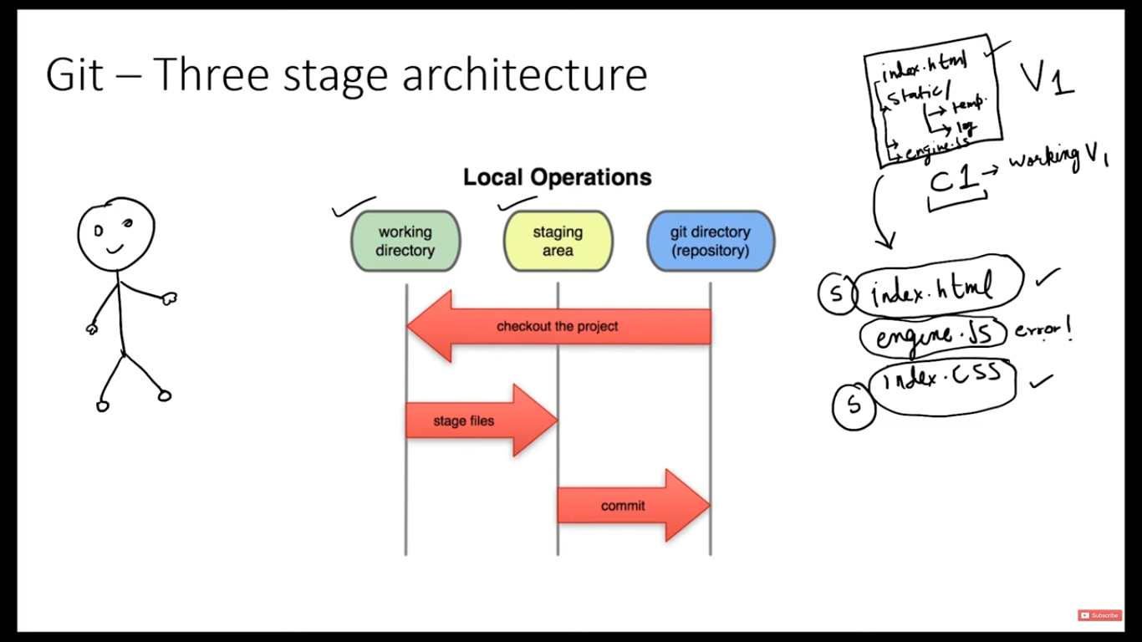

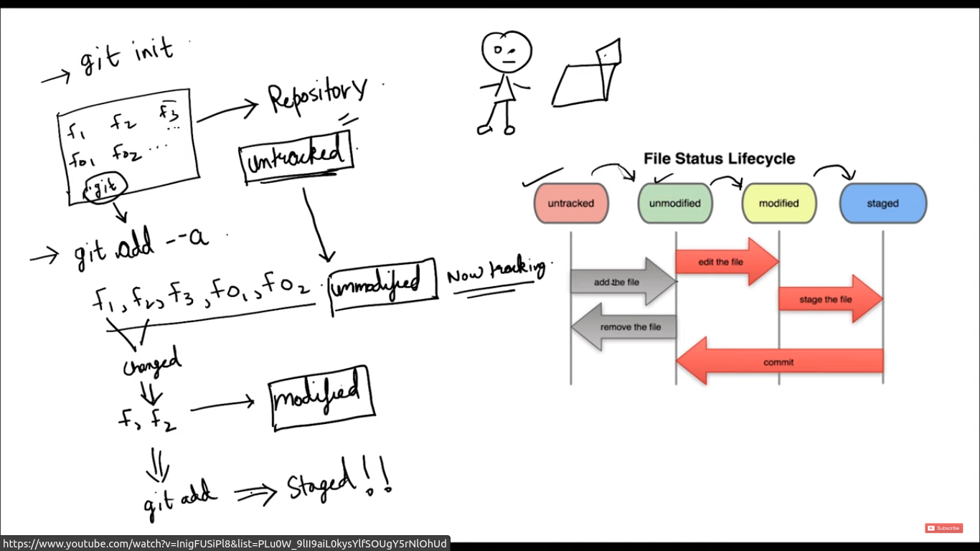

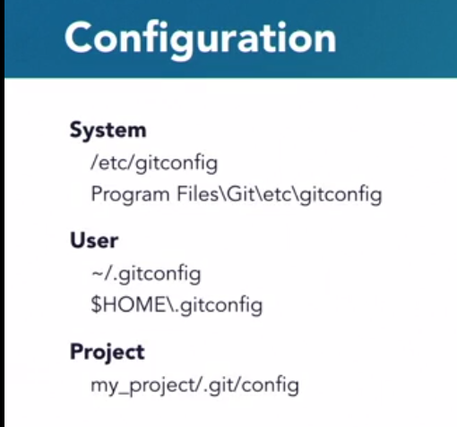
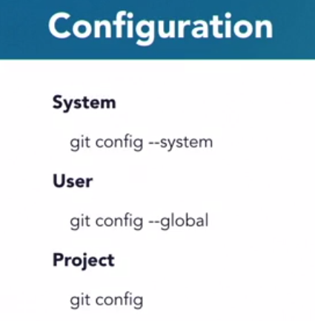

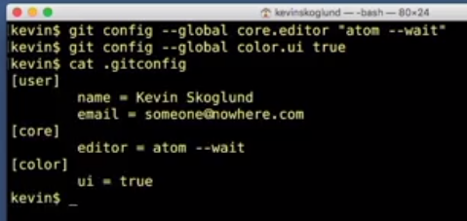
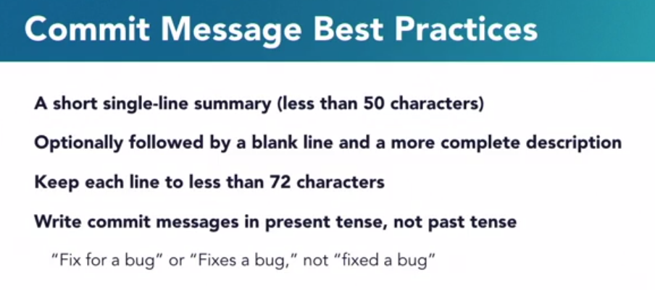
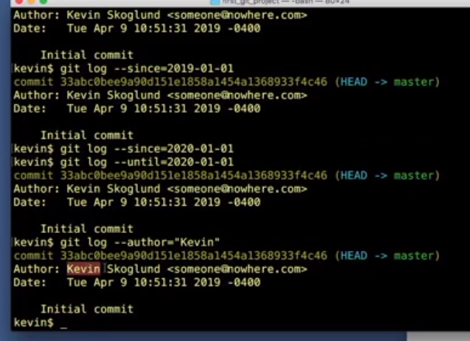

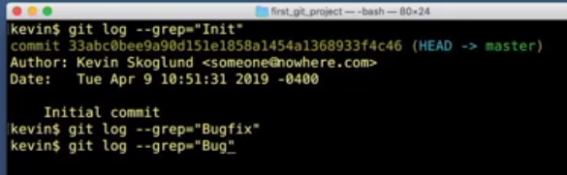
________________________________________________________________________________

Revert a commit:

git revert <Commit SHA Code>

Retrieve old version

git checkout <Commit SHA Code> -- file.txt (it will retrive the file.txt from old commits)

To delete untracked file in work directory
git clean [options]

-i == informative
-n== it will not delete but it will list files which can be deleted
-f == force it will remove that files

List of last commited files and directories
git ls-tree HEAD

To add empty directory to github
create a new file with name .gitkeep in the empty directory

